10/11/2021

Asst. Prof. Dr. Uğur CORUH

Recep tayyıp erdogan unıversıty

CE103 Algorithms and Programming- I 2021-2022 Fall Week-2 Lecture Notes and Topics

Workshop



Turn Windows Features On/Off

Search for "Turn Windows features on or off" and open the window

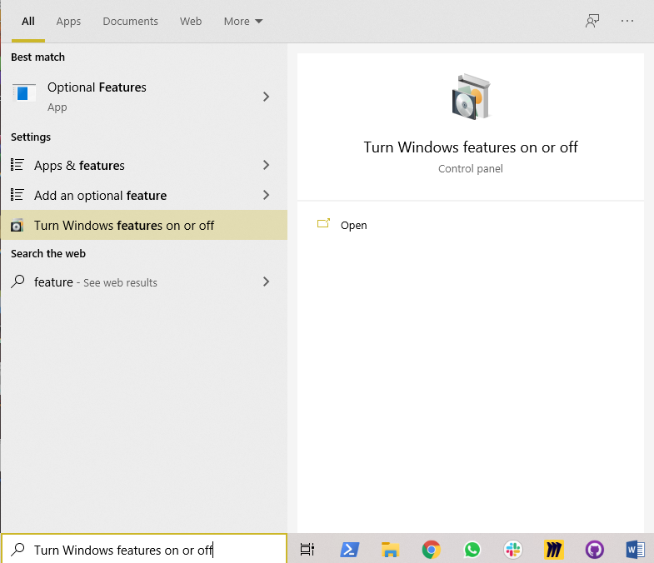

If you see something unchecked in the opening window, these components or applications/services are not installed or enabled on your operating system. Just select the required application and select "OK."

Or you can access it by opening **Control Panel** and click **Programs and Features > Turn Windows features on or off**.

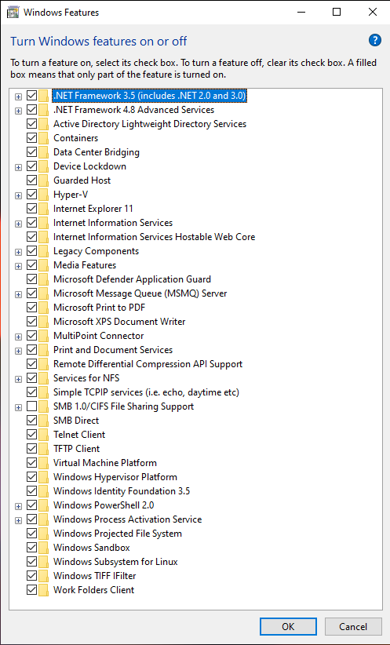

In our solutions, we will need the following, but you can enable and test their features independently.

* Windows Subsystem for Linux (WSL)
  + After WSL activation, please follow the instruction below until NS3 installation.
    - <https://github.com/ucoruh/ns3-wsl-win10-setup>
* Windows Powershell 2.0
* Microsoft Message Queue (MSMQ) Server
* Internet Information Services (IIS)

In each selection, expand and select unchecked features.

Folders and Views on Linux and Windows

In Windows operating system, Win+E is a shortcut to open an explorer.

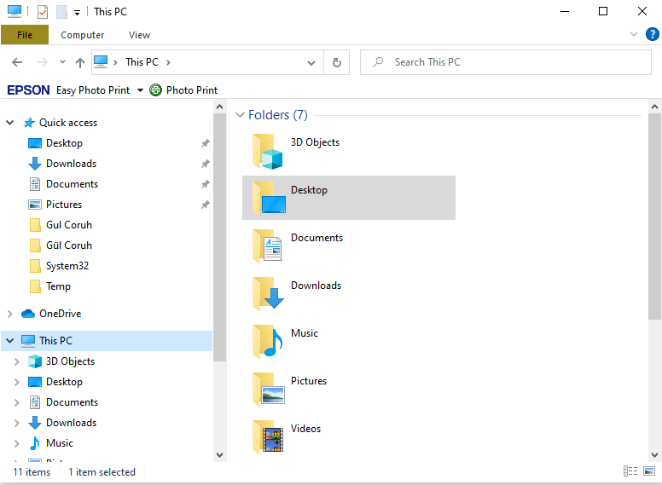

You can configure file extension visibility and folder or file visibility via the "view" section

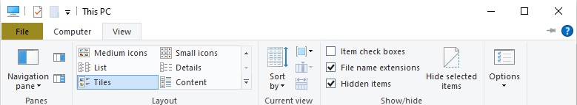

Visibility configuration is important to see all hidden files and file extensions on your operating system. A virus application can get a folder icon with the *.exe extension, and if you do not see the file extension, you can run this virus or malware on your computer.

Linux operating system does not need extensions, and file type is part of the file name.

System folders for Linux and Windows

Each operating system has different folders to keep the operating system and its application parameters, storage, and binaries.

Windows folders are listed in the following link

<https://en.wikipedia.org/wiki/Special_folder>

When you install an application to your computer, it is generally installed on the "C:\Program Files (x86)" or "C:\Program Files" folder in C volume. Also, your operating system folder will be installed on "C:\Windows."

32-bit applications will be installed on "C:\Program Files (x86)," and 64-bit applications will be installed on "C:\Program Files."

Program-related data files can be stored in "C:\ProgramData." It's a hidden folder.

User-related data files are stored in “C:\Users\<username>” and user-related application data files are stored in “C:\Users\<username>\AppData.”

Desktop folder for each user stored on "C:\Users\<username>\Desktop."

For Linux operating system, you can check the following link

<https://www.linux.com/training-tutorials/linux-filesystem-explained/>

/home folder is our base, and we can mount and communicate with external resources via /mnt folder.

For a more detailed Linux tutorial, please follow the tutorial below

<https://www.youtube.com/watch?v=V1y-mbWM3B8&ab_channel=Guru99> (2h 20m)

Windows CLI (Command Line Interface)

Win+R will open Run and type "cmd" and enter basic CLI for windows. Also, you can enter the C:\WINDOWS\system32 folder and run cmd.exe. Any executable binary in system32 can be run by writing its name to the console.

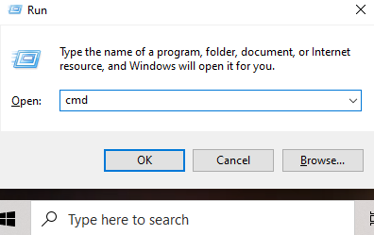

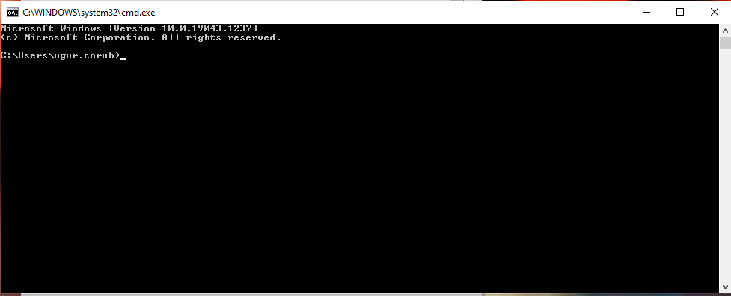

Windows System Environment Variables

System-level variables mean you can use this variable via its name. If any computer that uses the Windows operating system has the same name variable, you can access its content. The content can be different. For example, JAVA_HOME is defined for the Java installation directory. This variable keeps the java home folder path. If you develop an application that needs to use JAVA_HOME, you can use its variable name. You do not need to know the variable value because it's not a static variable and can be changed via user selection during installation.

You can enter via search "Edit system environment variables."

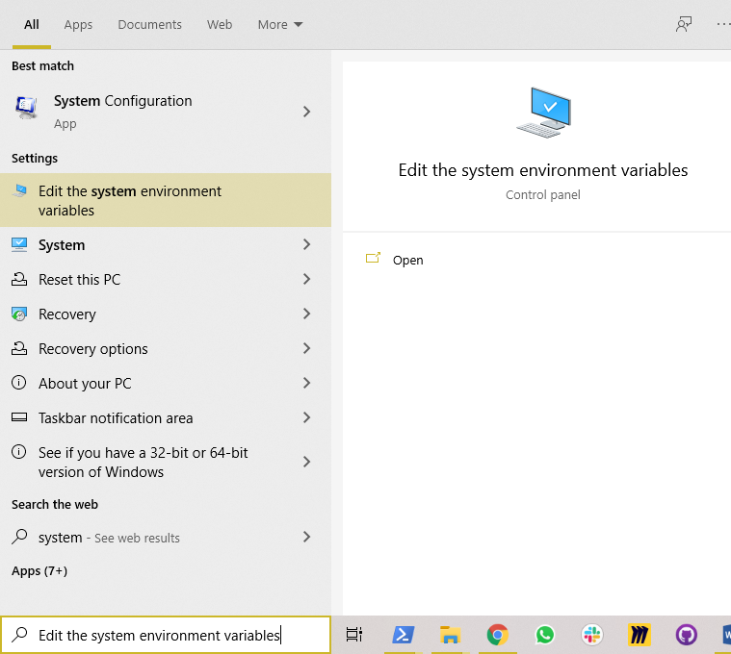

Or you can open window via **This PC -> Properties -> Advanced System Settings -> Advanced Section (Environment Variables)**

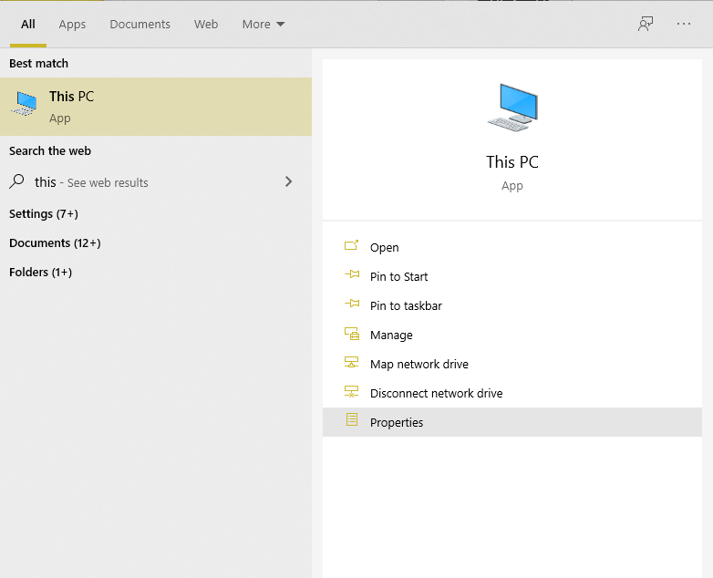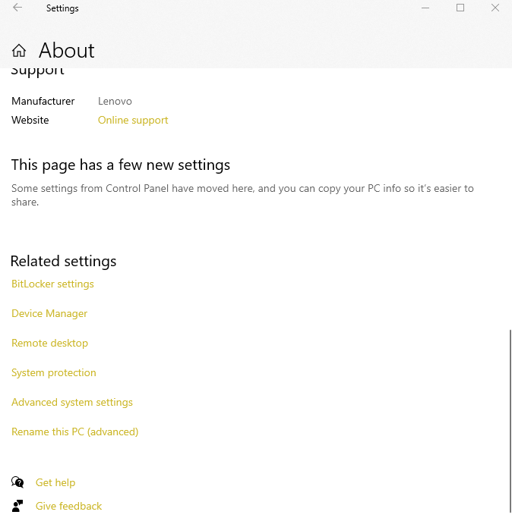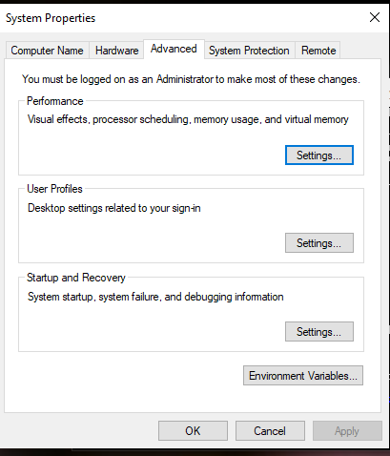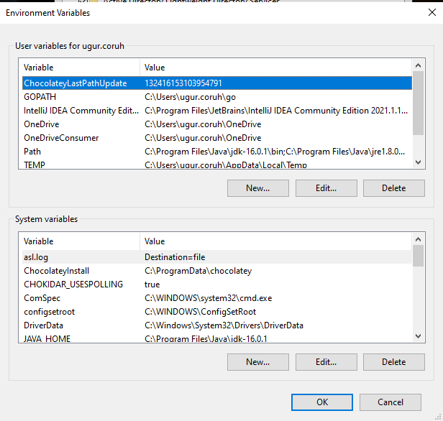

If you want to define a system parameter to use in the overall system, you should set this as a system variable; otherwise, you can set it as a user variable.

If you want to run an executable in the command line, you should add this executable path to the "path" variable in the system variables window

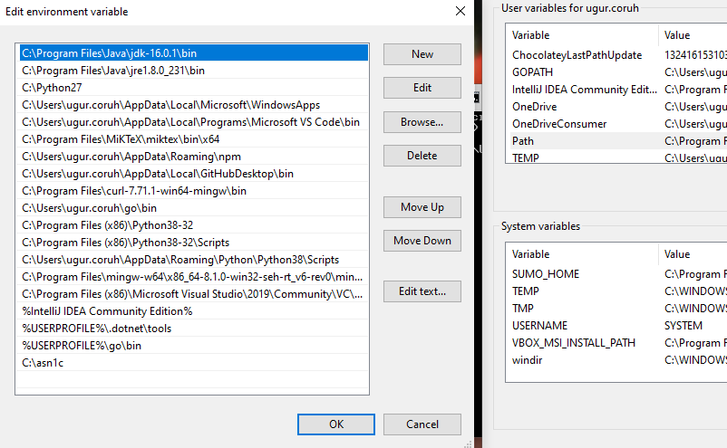

Be careful about ordering. If you have the same binary names in the "path" definition, the first binary in this list will be run in the command line.

Windows Boot / Service / Startup Configuration and Tools

Open Start -> Run and write "msconfig" command.

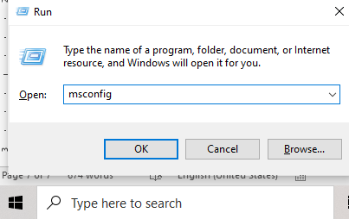

In the general tab if you uncheck Load startup items "startup" section applications and scripts will be disabled and this will speed up your operating system startups.

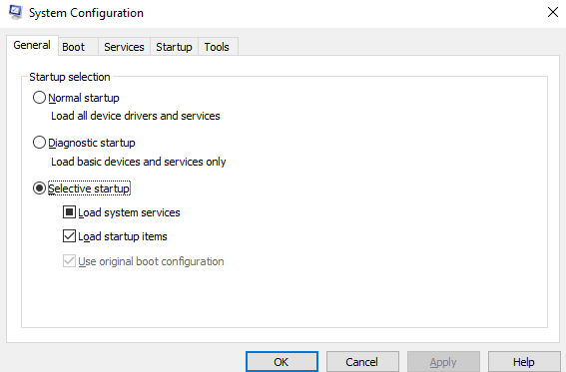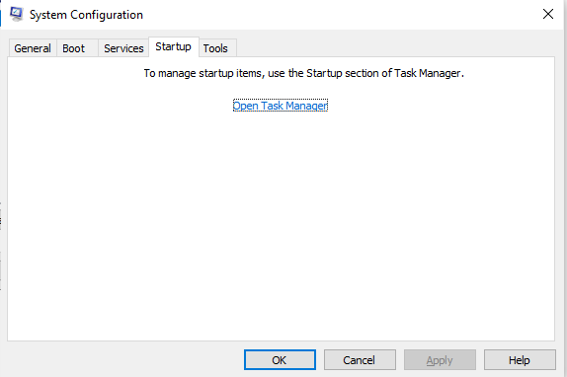

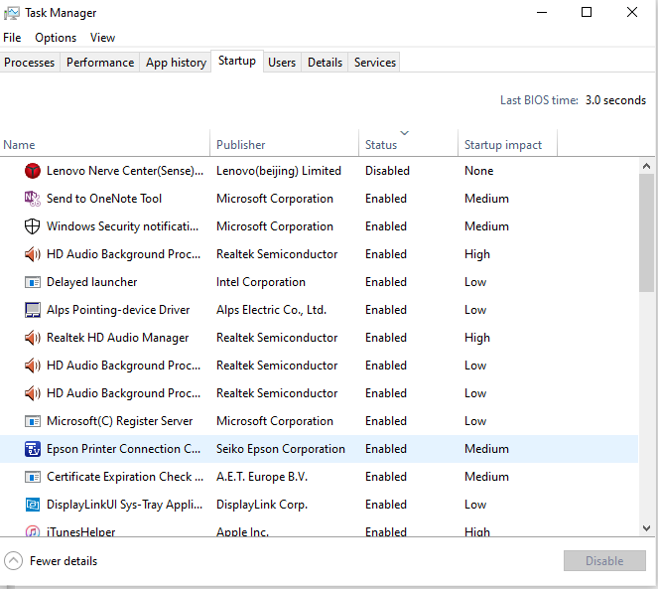

Startup items are listed in task manager. Be carefull about unwanted applications and scripts in this list. To speed up computer startup you can disable startup services but if you need them you should manually start via services window. In the services window you can see all services. Hide Microsoft services with checkbox and disable other services if you need speed.

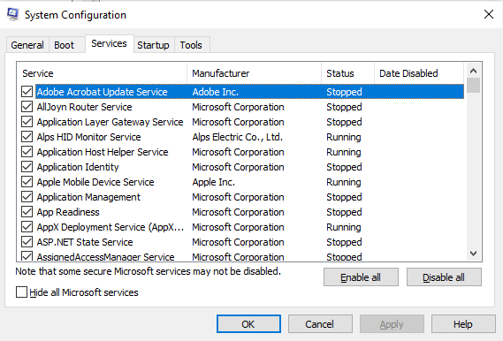

In boot screen you can disable boot GUI and see other operating systems that installed on your computer.

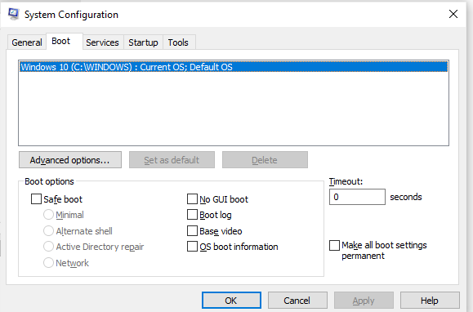

In the tools section you can find several tools to access management and configuration windows.

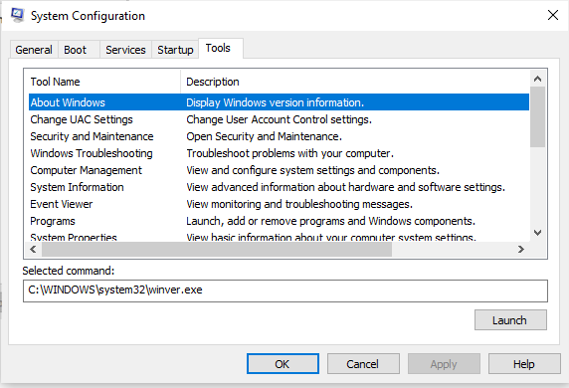

Windows Services

Services are unattended applications that process operating system or user required tasks. You can access services with Start->Run->Write "services.msc"

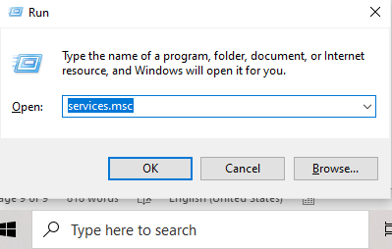

You can see a list of services, their status, and startup types also their running users. In the following sample, the Filezilla FTP server is service-disabled and not running. Also, we can see its service application binary path.

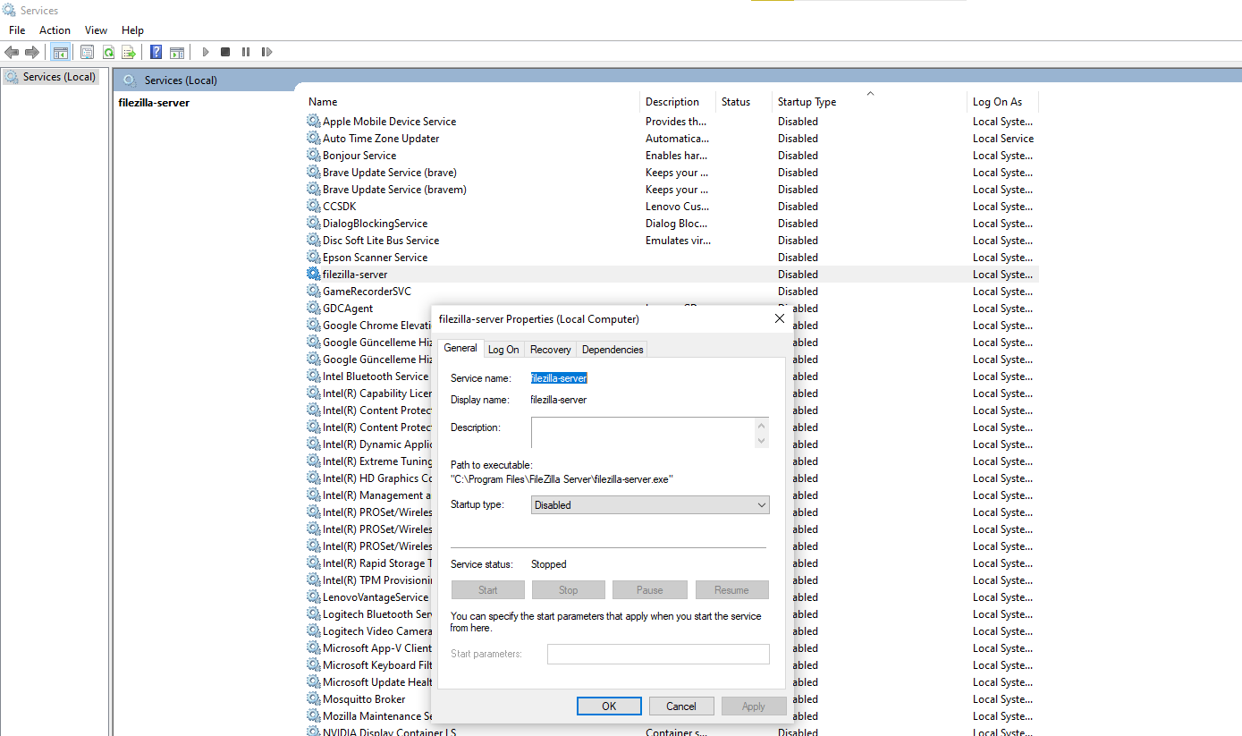

To understand how a service application runs and processes in windows operating system, please read the following article and sample

<https://www.codeproject.com/Articles/499465/Simple-Windows-Service-in-Cplusplus>

In this sample, there is basic windows service application. You do not need to understand it now, but try to figure out what it looks like. (in C++)

Also, I advise you to read the following entry on StackOverflow

<https://stackoverflow.com/questions/415409/run-batch-file-as-a-windows-service> and check

<https://nssm.cc/download>

Manage Computer

The computer management window can be opened with Start -> Run -> Write "compmgmt.msc" or search for This PC and select Manage.

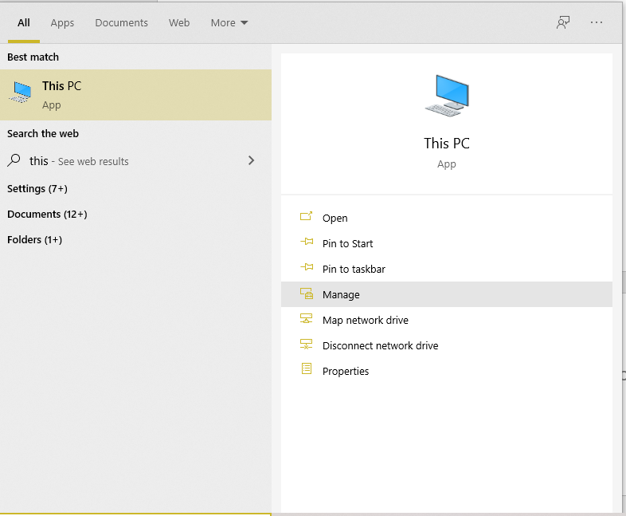

In the management screen, we have system tools, storage and services, and applications.

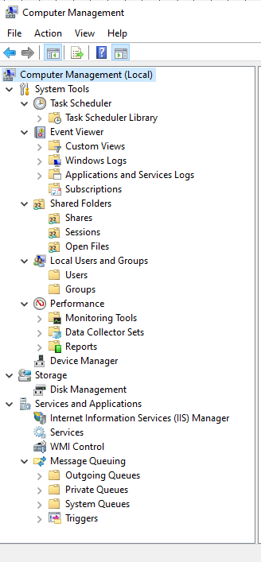

Task scheduler can process tasks with your time and trigger configurations. Tasks can be application or script files (*.bat)

In the task scheduler, you can make repeated processes as scheduled tasks.

Event viewer is a log viewer. System logs and custom applications logs can be checked with this window.

Device manager shows installed devices on your computer, and you can update their drivers or add new devices by using this window.

In storage management, you can check your physical storage devices and their segmentations. Creating a new volume or merging operations are processed via this window.

Services and Applications section provides you with IIS, a windows web server where you can serve custom web pages, FTP services, etc. IIS has several features and extensions on it to configure. Also you can use dynamic DNS services such as <https://www.duckdns.org/>, and by using this, you can access your home network services remotely with a domain name. You can configure Arduino or Raspberry PI devices for dynamic DNS service clients. You can check <https://www.arduino.cc/reference/en/libraries/easyddns/>

Services section, you can see all service configurations and status. Also, you can update service configurations and status by using this window.

WMI provides operating system component information. WMI code creator tool used to read this information source. This tool automatically creates code for you to use WMI services. You can download and try from the following link:

<https://www.microsoft.com/en-us/download/details.aspx?id=8572>

Remote Connections

File transport protocol (FTP) is used for central file sharing. <https://en.wikipedia.org/wiki/File_Transfer_Protocol>

Filezilla can be used as an FTP server. Also, it provides separated FTP client application

<https://filezilla-project.org/download.php?type=server>

<https://filezilla-project.org/download.php?platform=win64>

IIS also can provide an FTP server for the windows platform. Also, you can use MobaXterm <https://mobaxterm.mobatek.net/> In the servers menu, and you can configure for FTP server.

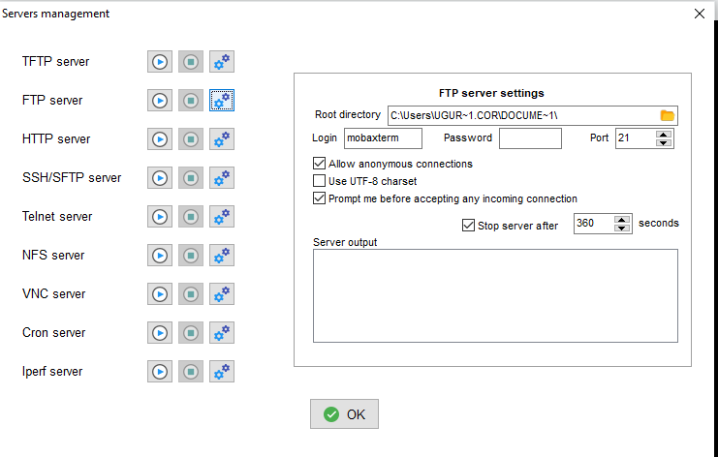

MobaXterm also provides FTP client

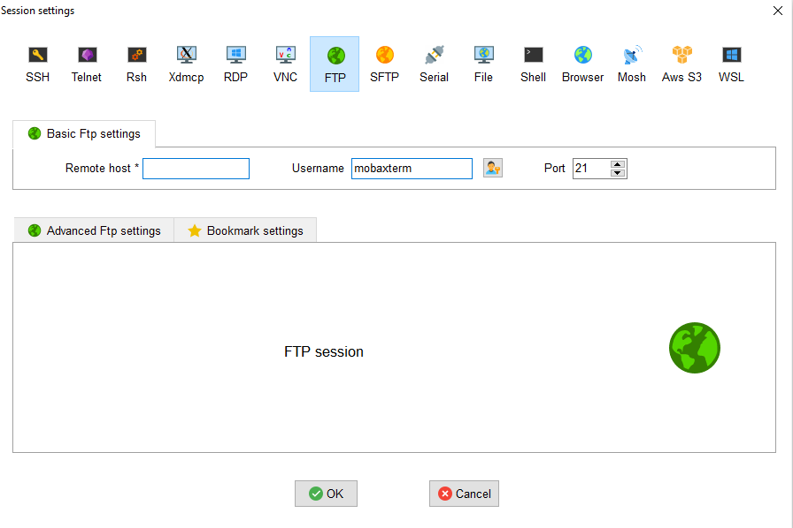

With mobaXterm, you can use the following connection protocols

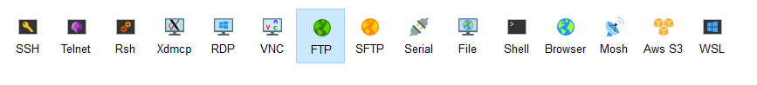

If you need to access the remote computer system without GUI, you can use an SSH connection. For this connection, you can use MobaXterm and Putty. SSH connection provides you CLI (command line interface) for interaction. With CLI, you can run applications and system commands.

If you need GUI, you can use RDP for the windows platform and XRDP for Linux platforms.

In the windows platform, you can run the "mstsc" command to open an RDP connection.

CLI video recording can be hard for tracking, and you can use <https://asciinema.org/> to save operations.

Numerical Systems

## Binary System

Base 2 number system



Image Ref: <https://sites.google.com/site/syhsguzmancsp/creative-projects/binary-numbers>

## Hexadecimal System

Base 16 number system

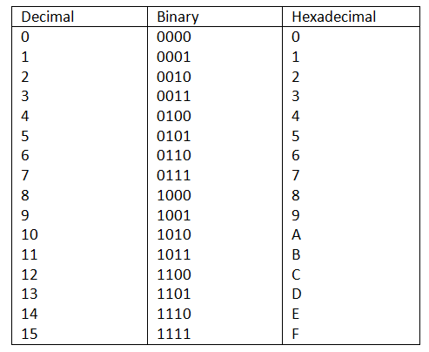

Image Ref: <https://sites.google.com/site/numbersystemscup/octal-number-system>

## Decimal System

Base 10 number system

Character Encodings

UTF-8 / ASCII

<https://en.wikipedia.org/wiki/UTF-8>

<https://www.asciitable.com/>

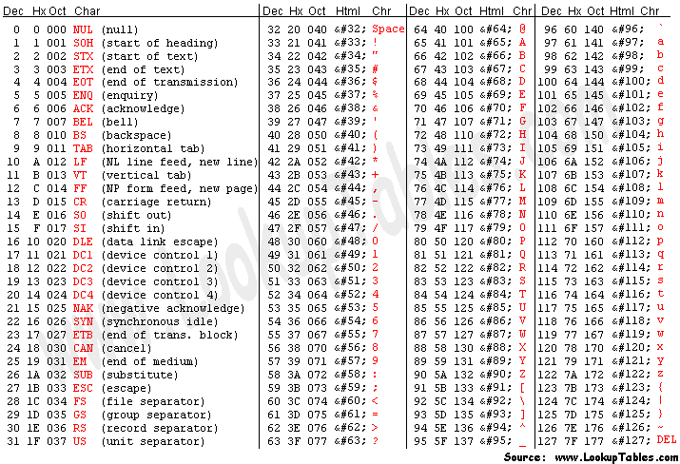

UTF-16

<https://en.wikipedia.org/wiki/UTF-16>

UTF-32

<https://en.wikipedia.org/wiki/UTF-32>